LAB 3: Layered Architecture Implementation (CRUD)
1. Objectives
Lab 3 implements a layered architecture for the product management functionality of the ShopSphere system using Node.js and Express.
The system fully implements CRUD:
- Create Product
- Read Product
- Update Product
- Delete Product
Processing flow:
Controller → Service → Repository → Database

2. Technology used
Technology | Role
Node.js | Runtime JavaScript
Express.js | REST API
JavaScript | Programming languages
In-memory Object | Database emulation

3. Directory structure
shopsphere_layered/
│
├── presentation/
│ └── product_controller.js
│
├── business_logic/
│ ├── models/
│ │ └── product_model.js
│ └── product_service.js
│
├── persistence/
│ └── product_repository.js
│
└── app.js

4. Layers in the system
Presentation Layer
- Receive HTTP Request
- Return JSON Response
- Call Service Layer
File:
product_controller.js

Business Logic Layer
- Business process
- Validate data
- Check the business rules.
File:
product_service.js
Business Rules:
- Names must not be empty.
- Price > 0
- Non-negative stock

Persistence Layer
- CRUD data
- Access the database
File:
product_repository.js
Simulated database:
let productDB = {};

5. CRUD APIs
Method | API | Function
POST | /api/products | Add product
GET | /api/products | Get the product list
GET | /api/products/:id | Retrieve products by ID
PUT | /api/products/:id | Product update
DELETE | /api/products/:id | Delete product

6. Data processing flow
Client Request
↓
Controller Layer
↓
Service Layer
↓
Repository Layer
↓
productDB
The data is then sent back to the client as a JSON response.

7. Layered Architecture Diagram
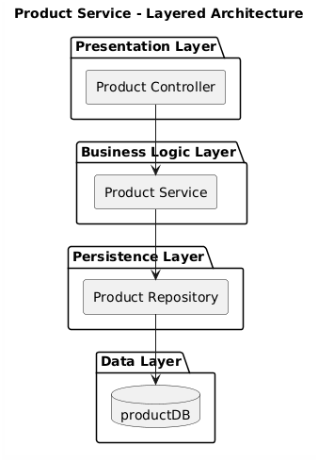

8. How to run the system

Install the library.
npm install express

Run the server
node app.js
Server runs at:
http://localhost:5003/api/products

9. Test API

Create product
curl -X POST http://localhost:5003/api/products \
-H "Content-Type: application/json" \
-d '{"name":"Nike Air Max","price":2500000,"stock":50}'

Get the product list
curl http://localhost:5003/api/products

Product update
curl -X PUT http://localhost:5003/api/products/1 \
-H "Content-Type: application/json" \
-d '{"price":2200000}'

Delete product
curl -X DELETE http://localhost:5003/api/products/1

